FOR IMMEDIATE RELEASE
Press contact: Christina Jensen | Jensen Artists
646.536.7864 x1 | christina@jensenartists.com

Cantaloupe Music Releases Evening Light: Raga Cycle I on March 20

By Michael Harrison and Ina Filip

First Single, Water Jhala, Out Today
Listen Now

Live Performance During Bang on a Can’s Long Play Festival
April 30-May 3, 2026 in New York
Information & Festival Tickets

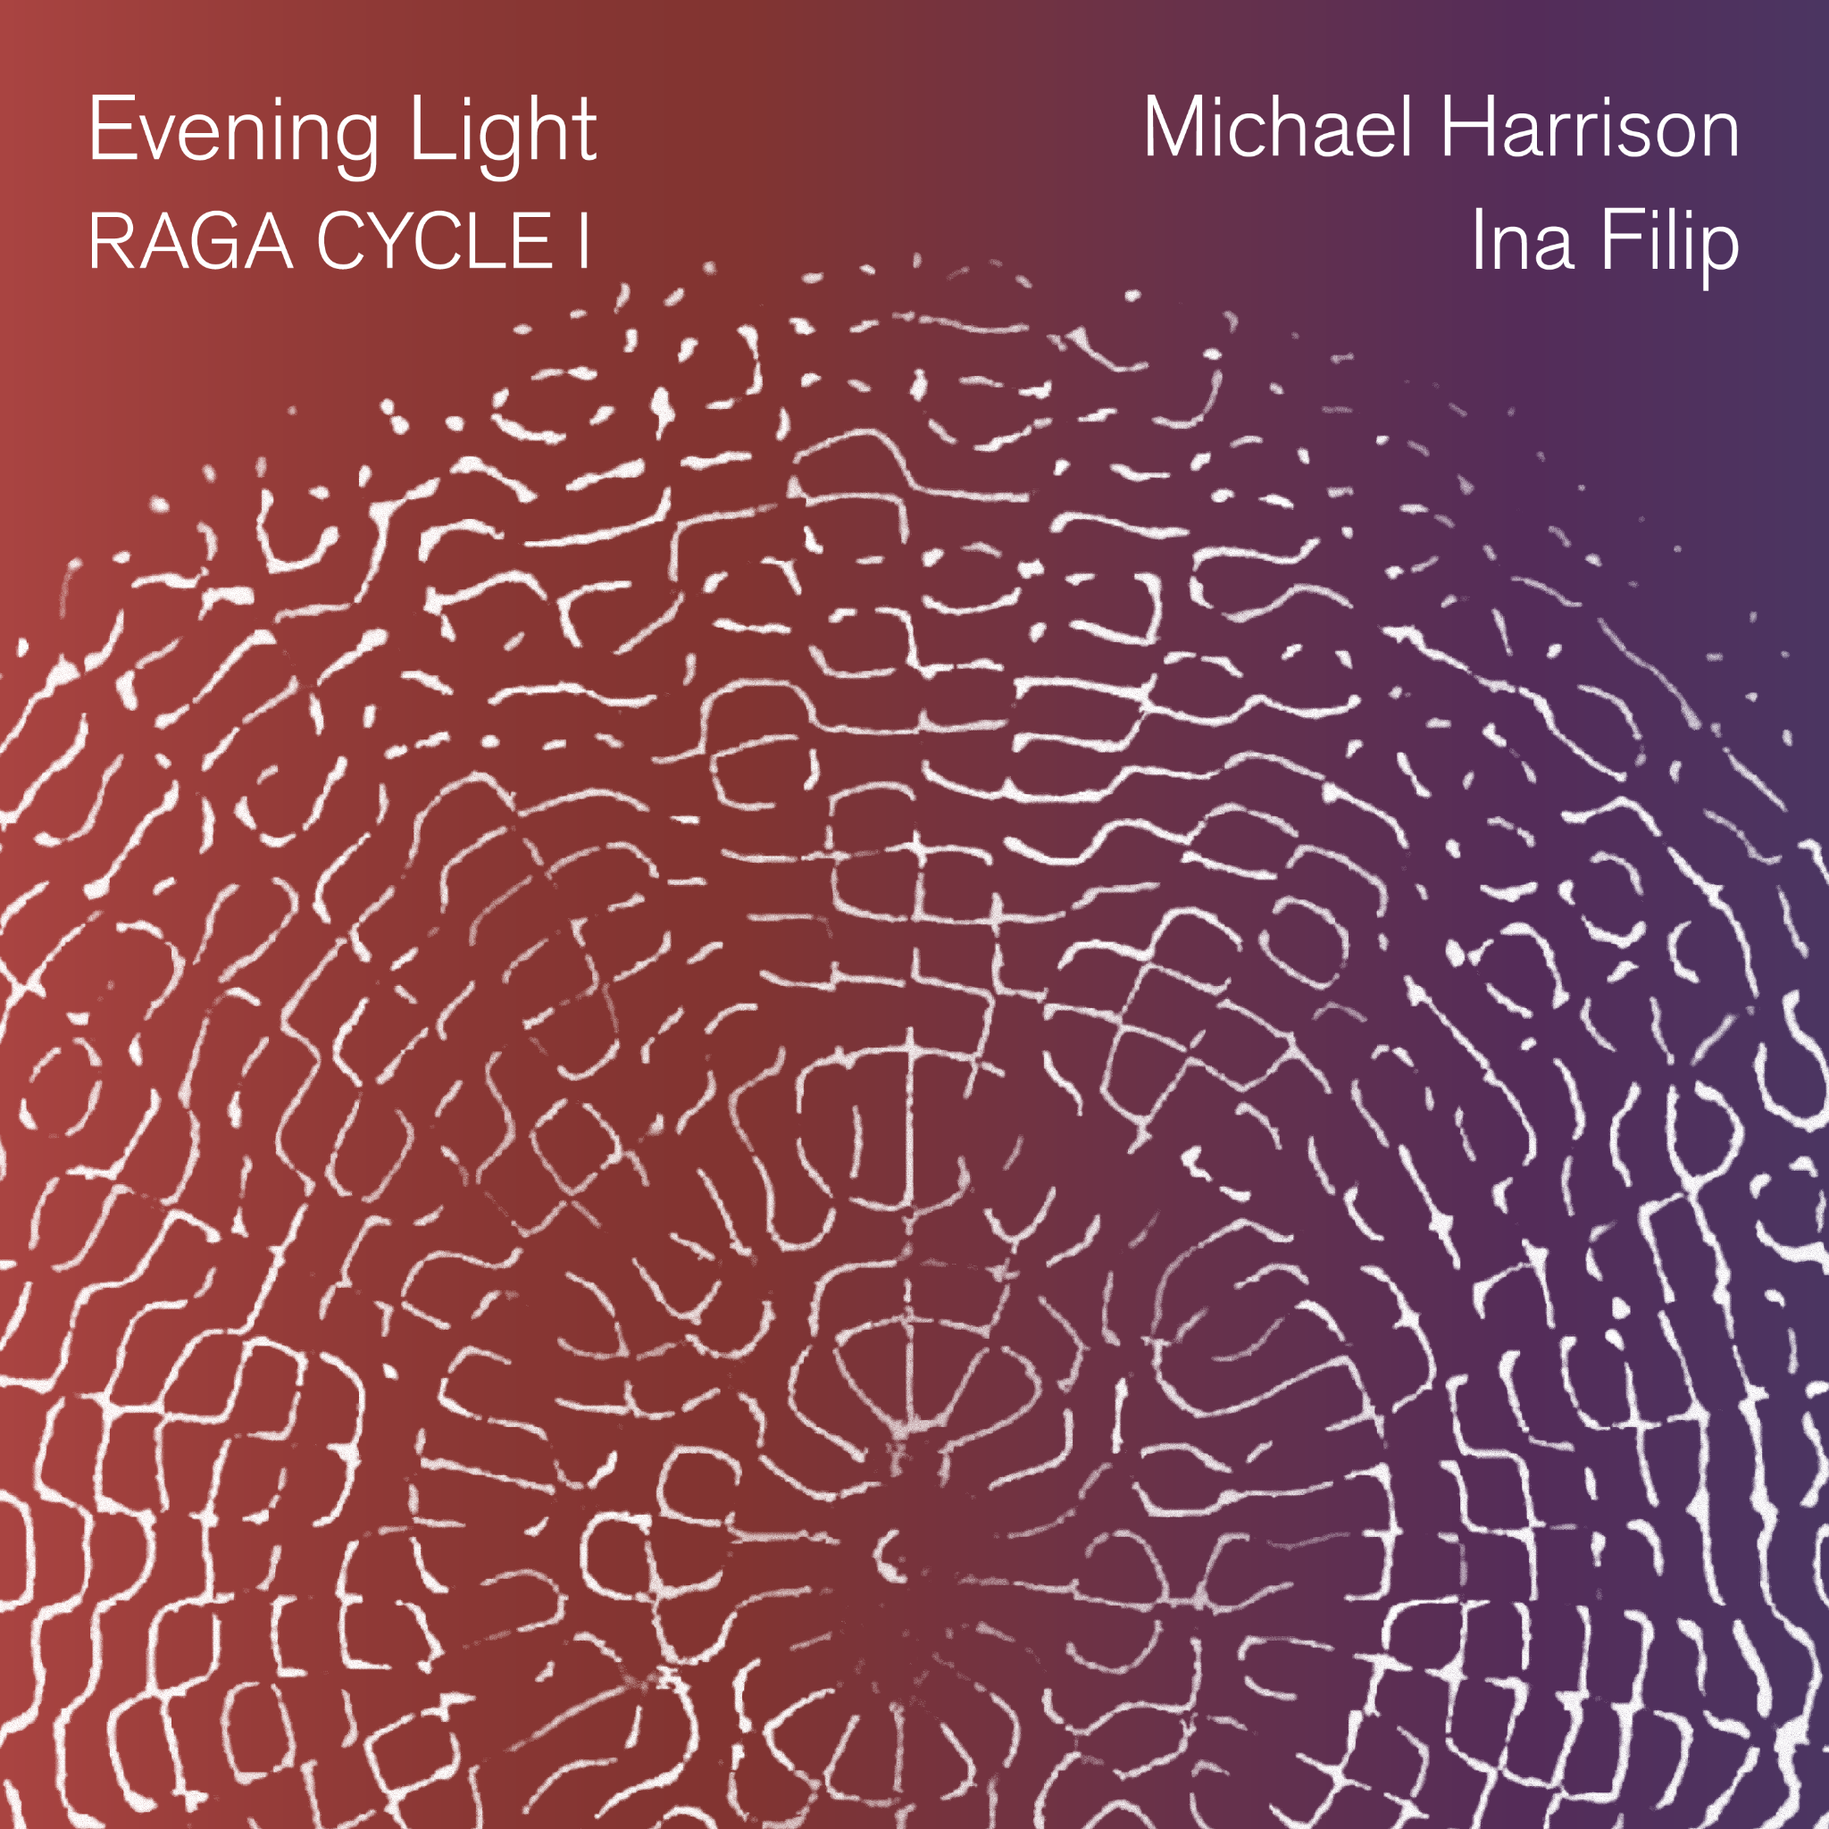
Album art and photos available here.

“music of positively intoxicating beauty” – Steve Smith, The New Yorker, on Harrison’s music

www.michaelharrison.com | www.inafilip.ca | www.cantaloupemusic.com

Note: Private album streams and downloads, not for publication, will be available to press in late February.
This is a digital-only release.

New York, NY (February 20, 2026) – On March 20, 2026, coinciding with the spring equinox, Cantaloupe Music will release Evening Light: Raga Cycle I. The new album opens the first chapter of the Raga Cycle, an eight-album series conceived by celebrated composer/pianist Michael Harrison, featuring collaborations with a range of musicians from around the world. Each album corresponds to a different three-hour segment of the day and night, following the Indian raga time cycle. This first installment, co-composed with vocalist Ina Filip (originally from Brazil and based in Québec), blends Indian classical ragas with lyrical and minimalist piano, multi-layered vocals, and electroacoustic textures. The album also features composer Elliot Cole on synthesizer, French composer Benoit Rolland on electroacoustics, and Bangladeshi tabla virtuoso Mir Naqibul Islam. Water Jhala, the first single, is available today. Harrison, Filip, Cole, Islam, and Hansford Rowe will perform Evening Light live during Bang on a Can’s Long Play Festival in New York, which runs April 30 to May 3, 2025.

Ragas are structures for melodic improvisation that capture a specific attitude, mood, and spiritual reality. In India they have been transmitted aurally from teacher to student for hundreds of years. Michael Harrison has studied this music devotedly for over 40 years with masters Pandit Pran Nath (alongside Terry Riley and La Monte Young) and Ustad Mashkoor Ali Khan.

Evening Light centers on the ragas Yaman and Bhupali, inhabiting the atmosphere of early evening — traditionally associated with expansiveness, luminosity, and quiet intensity. At its core is a finely shaped exchange between Harrison’s just intonation piano — the result of four decades of experience bridging Indian and Western classical traditions — and Filip’s voice. Harrison’s just intonation tuning system means the intervals are pure and uncompromised, creating a more beautiful resonance than traditional equal-tempered pianos, and more faithfully matching the tuning of traditional Indian ragas. Grounded in the discipline of Dhrupad, yet expansive in scope, Filip’s vocal writing shapes layered architectures and intricate interplay with the piano. Together their work melds the musical worlds of North India with those of Europe and America.

The opening Water Jhala — the album’s lead single, out today — unfolds through an intricate voice-and-piano exchange. In Angelim Tree the artists use low-register vocals and delicate piano lines to create an atmosphere of intimacy yet intensity. In Evening Light, the calm interplay is intended to draw the listener into stillness. Woven Sky unfolds through gradually shifting piano ostinati and quietly evolving harmonies, contrasting with the kinetic drive of Harrison’s Tarana Counterpoint – a polyphonic arrangement of a traditional melody attributed to 13th century musician and poet Amir Khusrau. Mahadev stands as a luminous devotional rendering, and the final track, Désancrage, closes the album in a poignant and intimate reflection.

Michael Harrison’s latest album Seven Sacred Names (Cantaloupe 2021) features performances by Grammy-winning Roomful of Teeth, violinist Tim Fain, cellist Ashley Bathgate, and others, with Harrison on piano. Just Constellations commissioned and recorded by Roomful of Teeth (New Amsterdam 2020), was called “glacially beautiful” and “luminous” by Alex Ross in The New Yorker and selected for NPR's Best 100 Songs of 2020 and Bandcamp's Best of Contemporary Classical 2020. His Time Loops album (Cantaloupe 2012) was chosen for NPR's Top 10 Classical Albums of 2012. His work, Revelation (Cantaloupe 2007), achieved international recognition and inclusion in the Best Classical Recordings of 2007 selections of The New York Times and Boston Globe and was called “the most brilliant and original extended composition for solo piano since the early works of Frederic Rzewski three decades ago” by Pulitzer Prize-winning critic Tim Page. Harrison’s music has also been recorded on Innova, New Albion, New World, and Important Records.

More about Michael Harrison: Composer/pianist Michael Harrison (called “an American maverick” by Philip Glass) forges a new approach to composition through just intonation (the system of tuning based on pure harmonic proportions). His works blend classical music traditions of Europe and North India. He is a Guggenheim Fellowship and NYFA Artist Fellowship recipient.

Harrison creates dedicated tuning systems for many of his works. He pioneered a structural approach to composition in which the proportions of harmonic relationships organically determine other musical elements such as pitch, duration, and dynamics. He also invented the "harmonic piano," a grand piano that plays 24 notes per octave, documented in the Grove Dictionary of Musical Instruments. Harrison seeks expressions of universality via the physics of sound — music that brings one into a state of concentrated listening as a meditative and even mind-altering experience.

His music has been performed at BAM Next Wave Festival, Carnegie Hall, Lincoln Center, Metropolitan Museum of Art, Museum of Modern Art, Park Avenue Armory, the Louvre, Centre Pompidou, MASS MoCA, Big Ears Festival, Spoleto Festival USA, the United Nations, Klavier Festival Ruhr, and the Sundance Film Festival. His recent engagements include the Minimal Music Festival at the Muziekgebouw in Amsterdam, the Italian Virtual Pavilion of the Venice Biennale 2021, the Mattatoio Museum in Rome, and the Institute for Advanced Study at Princeton. Harrison collaborates with performers including Alarm Will Sound, Cello Octet Amsterdam, Maya Beiser, Clarice Jensen, Del Sol String Quartet, and Contemporaneous, who have commissioned his works using just intonation. He has collaborated with visual and media artists, choreographers, and filmmaker Bill Morrison.

While still an undergraduate student, Harrison met composer La Monte Young. Soon Young brought him to New York as his protégé to study composition, performance, and Indian classical music. Harrison was the exclusive tuner for Young's custom Bösendorfer concert grand and became the only person other than the composer to perform Young's six-hour The Well-Tuned Piano. Living in Young's Tribeca loft during this formative decade, Harrison was immersed in the world of minimal music and art. Terry Riley became a close friend and mentor within a broader circle that included John Cage, Philip Glass, Laurie Anderson, Marian Zazeela, and the Dia Art Foundation's founders (the patrons of Harrison's work with Young). Most importantly, he became a disciple of Young and Riley's music guru, Pandit Pran Nath, traveling to India with Pran Nath and Riley for extensive study and practice periods.

Harrison’s residencies include MacDowell, Yaddo, Camargo, McColl Center, Ucross, Djerassi, Millay, Bogliasco, La Napoule, I-Park, MASS MoCA, and the Visiting Artists program of the American Academy in Rome. In addition to the Guggenheim, his awards include an Aaron Copland Recording Grant, Classical Recording Foundation Award, IBLA Foundation Prize, American Composers Forum residency and performance in the Havana Contemporary Music Festival, and a New Music USA Grant. Harrison received his Masters in Composition, studying with Reiko Fueting, at Manhattan School of Music.

About Ina Filip: ​​Ina Filip is a Brazilian-born vocalist and composer based in Québec whose work bridges Indian classical music, modal improvisation, and contemporary composition. Drawing on rigorous training and cross-cultural musical influences, she has developed a distinctive vocal and compositional language that is both deeply personal and creatively expansive.

She undertook intensive training in Dhrupad — the most microtonally refined and contemplative tradition of North Indian classical music — under the guidance of the Gundecha Brothers, widely regarded as the foremost living exponents of the form. Filip lived and studied for several years in their residential gurukul in India within the Guru–Shishya Parampara system, India’s traditional pedagogical system grounded in daily, long-term oral transmission between teacher and disciple. This rigorous formation immersed her in the raga system while cultivating advanced microtonal precision.

In parallel, her improvisational practice has been profoundly shaped by Bobby McFerrin’s vocal approach, which she has explored, studied, and embodied through years of playful experimentation and deep listening. Filip has developed a distinctive compositional approach that brings traditional vocal practice into contemporary contexts. Her work integrates layered vocal architectures, contrapuntal interplay, and electroacoustic textures, expanding the expressive possibilities of voice.

Her collaborative scope extends into interdisciplinary creation. She co-created the music for 24 Hours at Once, an installation with Harrison and filmmaker Bill Morrison, presented by Art Letters & Numbers (New York), and contributed to Passage, in collaboration with Harrison and visual artist Nina Elder, presented at the Turchin Center for the Visual Arts (North Carolina).

Filip’s voice has appeared in projects spanning ambient electroacoustic composition and raga-based vocal polyphony. Her discography includes Cantos de Ma, a solo album centered on voice and silence, and Polyphonic Malkauns, a contemporary raga reinterpretation created with composer Payton MacDonald. She has also contributed to the international electronic music scene through collaborations with producers including Soohan and Adham Shaikh, whose releases featuring her vocals reached global audiences.

Filip’s projects have been supported by the Conseil des arts et des lettres du Québec (CALQ) and the Canada Council for the Arts (CAC) through grants for composition, production and performance. She has also participated in artist residencies including Avaloch Farm Music Institute (New Hampshire) and Art Letters & Numbers (New York).

Across all her projects, Filip’s voice carries the discipline of long-dedicated practice and the freedom of improvisation, inviting listeners into a space of resonance, presence, and expanded perception.

ALBUM TRACK LISTING & CREDITS:
Evening Light: Raga Cycle I
Michael Harrison and Ina Filip
Cantaloupe Music
Release Date: March 20, 2026

1. Water Jhala (Raga Yaman)
2. Angelim Tree
3. Evening Light (Raga Yaman)
4. Woven Sky (Raga Yaman)
5. Tarana Counterpoint (Raga Yaman Kalyan)
6. Mahadev (Raga Bhupali)
7. Désancrage

Produced by Elliot Cole and Benoit Rolland
Engineered and mixed by Louis Morneau in Montreal

Michael Harrison, piano tuned in just intonation, vocals on Mahadev
Ina Filip, vocals
Elliot Cole, synthesizer, vocals on Tarana Counterpoint and Angelim Tree
Benoit Rolland, electro-acoustics, synth bass
Mir Naqibul Islam, tabla
Shawn Mativetsky, tabla on Tarana Counterpoint
Gabriel Cabezas, Audréanne Filion, cellos on Désancrage

All music composed by Michael Harrison and Ina Filip, except Désancrage composed by Michael Harrison, Ina Filip and Elliot Cole

Tarana Counterpoint and Mahadev are based on traditional melodies, adapted by Michael Harrison

The artists acknowledge the support of Conseil des Arts et des Lettres du Québec and the Canada Council for the Arts

Executive producers: Michael Gordon, David Lang, Kenny Savelson and Julia Wolfe
Cantaloupe Club Producers Circle: Patricia & Martin Angerman, Eric Scott Klein, Ken Nielsen, Roger Stude, Ola Torstensson
Label manager: Bill Murphy
Licensing manager: Brian Petuch
Label assistant: Yael Gordon
Art direction and graphic design: Noah Scalin/Another Limited Rebellion

Album cover image by Hans Jenny from his book Cymatics: A Study of Wave Phenomena and Vibration, used by permission from MacroMedia Publishing

# # #

